

IF…ELSE & ELSE IF STATEMENT,

TESTING SET OF CONDITIONS

Assignment # 12-13

JAVASCRIPT

1. Write a program that takes a character (number or string) in a variable & checks whether the given input is a number, uppercase letter or lower case letter. (Hint: ASCII codes:- A=65, Z=90, a=97, z=122).

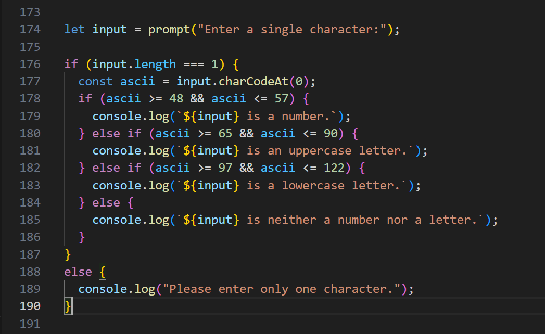

1. Write a JavaScript program that accept two integers and display the larger. Also show if the two integers are equal.

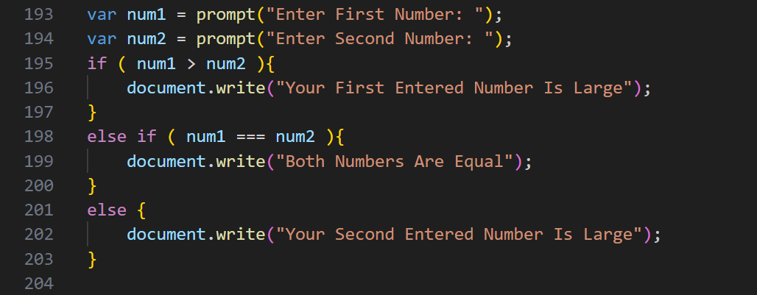

1. Write a program that takes input a number from user & state whether the number is positive, negative or zero.

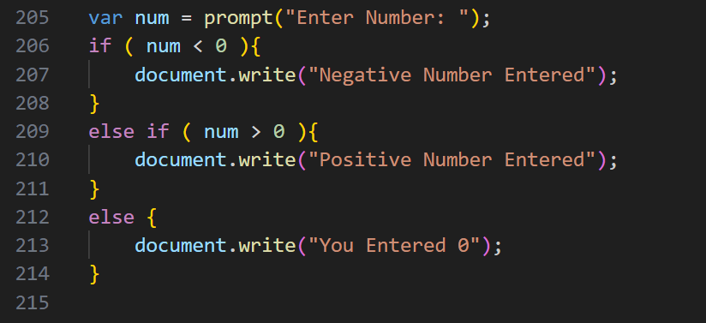

1. Write a program that takes a character (i.e. string of length 1) and returns true if it is a vowel, false otherwise

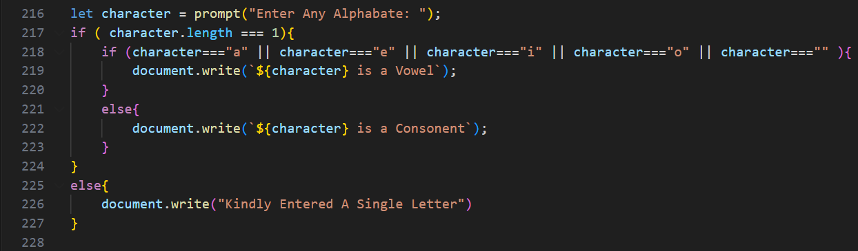

1. Write a program that
   1. Store correct password in a JS variable.
   2. Asks user to enter his/her password
   3. Validate the two passwords:
      1. Check if user has entered password. If not, then give message “ Please enter your password”
      2. Check if both passwords are same. If they are same, show message “Correct! The password you entered matches the original password”. Show “Incorrect password” otherwise.

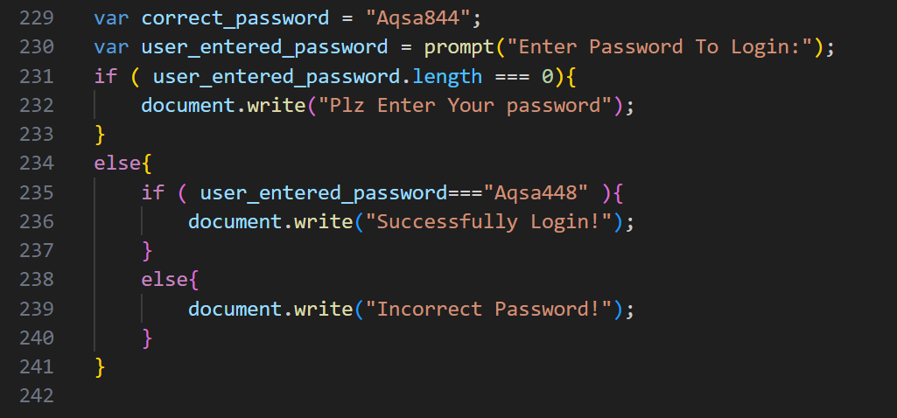

1. This if/else statement does not work. Try to fix it: var greeting;

var hour = 13; if (hour < 18) {

greeting = "Good day"; else

greeting = "Good evening";

}

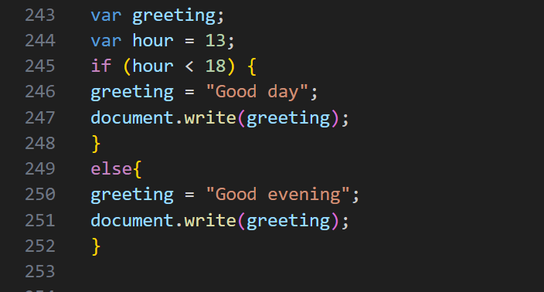

1. Write a program that takes time as input from user in 24 hours clock format like: 1900 = 7pm. Implement the following case using if, else & else if statements

